Ministry of Education and Science of Ukraine
Sumy State University (Ukraine)
The College of New Jersey (USA)
Camarines Sur Polytechnic Colleges (Philippines)
European Danube Academy (Germany)
University of Kragujevac (Serbia)

Dear colleagues,

We invite you to participate in the
1st International Scientific and Practical Conference
"Strategic Innovations of Social Communications and Foreign Philology in Crisis Times"
June 1, 2024

The conference will be held online in a hybrid format:

Synchronous: participation in sections
Asynchronous: submission of publications

Working languages: Ukrainian, English.

The conference will take place on June 1, 2024, on the Zoom platform.

Preamble
In light of the unprecedented challenges faced by societies worldwide, particularly in times of crisis, the importance of strategic innovations in social communications and foreign philology cannot be overstated. These disciplines play a crucial role in fostering resilience, adapting to changing circumstances, and navigating complex linguistic and cultural landscapes.
As we convene for this international conference call for proposals, themed "Strategic Innovations of Social Communications and Foreign Philology in Crisis Times," we aim to explore and showcase groundbreaking research and practices that address the pressing issues faced by language educators, media professionals, and scholars in today's volatile world.
Our conference will be structured around the following areas:
- Resilience and Adaptation in Language Education: Exploring Linguistic and Cultural Dynamics
- Media Innovations and Challenges: Navigating the Digital Landscape in Crisis Times
- Language Pedagogy in the Digital Age: Strategies for Effective Remote Teaching and Learning
- Interdisciplinary Approaches to Understanding Societal Dynamics: Insights from Psychology, Political Science, and Socio-Cultural Technologies
- Linguistic Diversity and Multilingualism: Safeguarding National Identity
Through these thematic tracks, we aim to foster collaboration, exchange insights, and inspire innovative solutions to the multifaceted challenges facing language education, media, and society at large.

Conference Objectives:
- To explore and discuss innovative strategies and approaches for fostering resilience and adaptation in language education and foreign philology.
- To examine the impact of media innovations and challenges on society, culture, and communication during crisis times.
- To share best practices and effective strategies for remote teaching and learning in the digital age, particularly in language pedagogy.
- To facilitate interdisciplinary dialogue and collaboration in understanding societal dynamics and addressing challenges from diverse perspectives.
- To highlight the importance of linguistic diversity and multilingualism in safeguarding national identity and promoting cultural heritage.
We invite scholars, researchers, educators, media professionals, policymakers, and practitioners from around the globe to submit their proposals and join us in advancing knowledge, fostering collaboration, and shaping the future of social communications and foreign philology in crisis times.

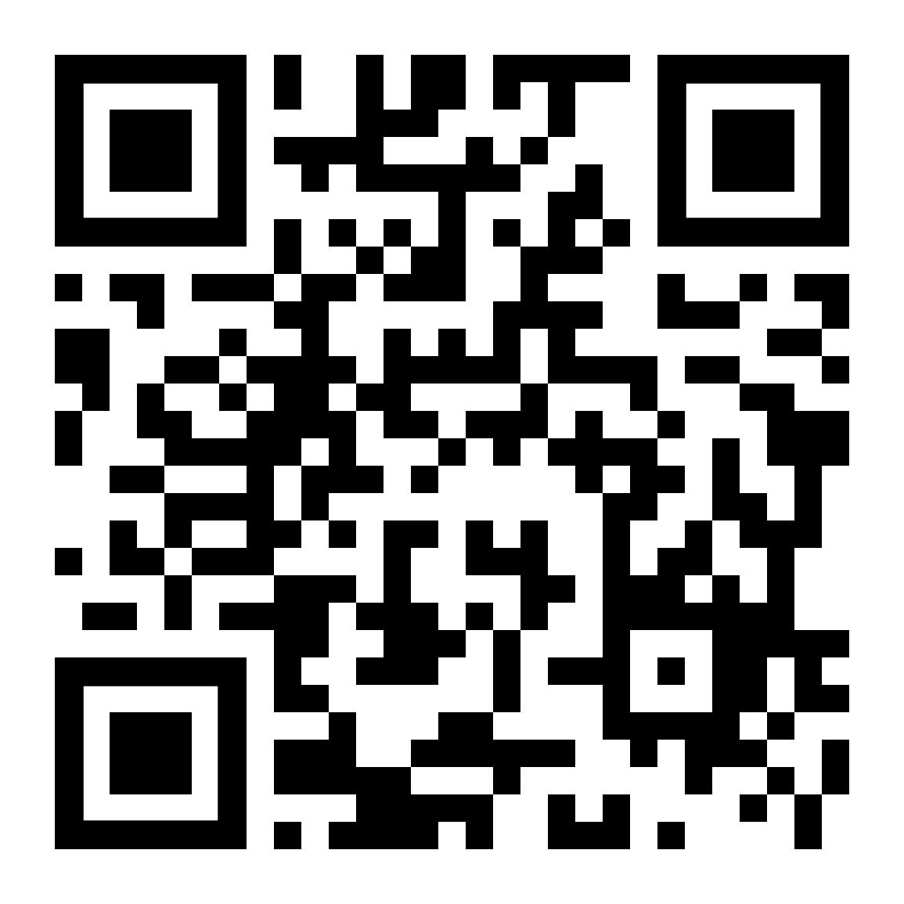
Important dates:
1. Registration is free and mandatory via the following link: https://forms.office.com/e/6Phaybkqez by May 20, 2024.
2. Submission of abstracts / articles: by May 27, 2024, to the email address conference.ifsk@gmail.com (with the subject line "1st International Scientific Conference 01.06.2024").
3. Notification of acceptance of conference materials and distribution of the conference program: May 27-29, 2024.
4. Conference: June 1, 2024.
5. Compilation of the conference abstracts collection: June 2-14, 2024.
6. Publication of the conference abstracts collection on the website of the Faculty of Foreign Philology and Social Communications, Sumy State University, and distribution of PDF copies to participants: June 15-16, 2024.

REQUIREMENTS FOR CONFERENCE PROCEEDINGS:

Following the conference, all accepted proceedings will be published in an electronic collection (PDF format) within two weeks after its completion and placed on the official website of the Faculty of Foreign Philology and Social Communications, Sumy State University, as well as emailed to all participants at the address provided in the questionnaire.
Full articles that undergo review and plagiarism-checking procedures will be published in professional journals of categories B, "Philological Treatises," and "Image," indexed in the Crossref database with the assignment of DOI.

Font: Times New Roman, size 14, line spacing - 1.5, paragraph indent - 1.25, all margins - 2 cm.
Volume: 2-4 pages.
Languages: Ukrainian, English.
Each table, illustration, diagram, scheme must be captioned and titled.
Graphical material should be created in programs available for further editing. For figures and tables, use Times New Roman font, size - 12 pt., line spacing - 1.
The number of co-authors of abstracts should not exceed three. The number of materials submitted by one author should not exceed two.
Works that do not meet the requirements or are submitted late will not be considered.

Sequence of placement of materials:
author's last name and initials;
ORCID;
academic degree and/or academic title (if available), position;
place of work or study (exact official name of the institution);
city, country.
Left alignment.
Then, through an interval, the title of the abstract is specified.

References (primary sources are provided in alphabetical order and formatted according to the requirements of the international APA Style 7. Internal references in the text are indicated in parentheses: (Author's Last Name, Year), reference in the narrative: Author's Last Name (Year).

For more information, visit: https://owl.purdue.edu/owl/research_and_citation/apa_style/apa_style_introduction.html

Sample:

Nabok, M.M.
ORCID: https://orcid.org/0000-0001-9422-730X000
Candidate of Philological Sciences
Associate Professor of the Department of Language Training for Foreign Citizens
Sumy State University
Sumy, Ukraine

ETHNOPSYCHOLINGUISTIC PARALLELS IN UKRAINIAN AND ARABIC LANGUAGES

Text, text, text

Literature:
Torino, G. C., Rivera, D. P., Capodilupo, C. M., Nadal, K. L., & Sue, D. W. (Eds.). (2019).Microaggression theory: Influence and implications. John Wiley & Sons. https://doi.org/10.1002/9781119466642
Dillard, J. P. (2020). Currents in the study of persuasion. In M. B. Oliver, A. A. Raney, & J. Bryant (Eds.), Media effects: Advances in theory and research (4th ed., pp. 115–129). Routledge.
Kurt Jooss. (n.d.). In Encyclopaedia Britannica. Retrieved April 29, 2022, from https://www.britannica.com/biography/Kurt-Jooss

Conference materials will be printed in the author's version. Participants of the conference are responsible for the scientific content and quality of the submitted materials. The organizing committee reserves the right to reject materials that do not meet the requirements or are submitted after the deadline.

